Ref. No: CHEM/0015 Date: 11/09/2023.

Notice Regarding submitting writing for Magazine
It is hereby notified to all students of 1st semester Chemistry major and minor, 2nd semester Hons, Programme & GE and 5th semester Hons, and Programme & GE students that in near future we will publish both departmental and wall magazine. In this regard all students are requested to submit their writings (basically on chemistry), photographs, and drawing, any design (for cover page) to any respective sir/madam on or before 25/09/2023. If there is any soft copy then please send to the following mail:
chemistry@srikrishnacollegebagula.ac.in

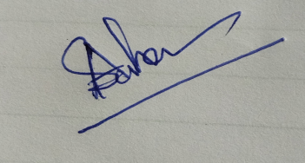
HOD
Department of Chemistry

